Presented by: ashish patel

NANO TEXT EDITOR

best editor ever

November 29, 2016

Introduction

The nano editor is designed to emulate the functionality and ease-of-use.

# In Shortcuts

^ - ctrl/esc+esc

M -esc/alt

Note - Alternative keys are shown in parentheses:

# Basic Shortcuts

Ctrl + t shows file view so we can select a file to edit

ctrl+G (F1) Display this help text

ctrl+X (F2) Close the current file buffer / Exit from nano

ctrl+O (F3) Write the current file to disk

ctrl and - decrease the text size in cmd size(always)

ctrl and shift and + increase the cmd size ( to learn ‘-’ is alone enough)

# Inserting Text From another Source

Step 1- ctrl+R (F5) Insert another file into the current one(cntrl+R means tell this file to read from other file )

Step 2 – enter file path or browse to file using ctrl+t , you can also get output of some command by executing command by ctrl+x then entering command

# Search

ctrl+W Search for a string or a regular expression

alt-W Repeat last search

# Find and Replace

alt-R Replace a string or a regular expression(ctrl+R se read from other file yaha replace to R se hi hona tha)  
cntrl + \ find and replace

# Cut and Paste

ctrl+K (F9) Cut the current line and store it in the cut buffer

ctrl+U (F10) Uncut from the cut buffer into the current line

# Copy and Paste

### For a line

(alt-6) Copy the current line and store it in the cutbuffer( to paste use ctrl+U uncut)

NOTE – it only copies one line

### for paragraphs

Step1- set mark , cntrl+^ (^ is used as mark)

step2- using navigation keys to select ( Î and lower key)

step3- use cntrl+k for cut or Alt+6 for copy

step4- use cntrl+u for paste

# Indentation

alt-} Indent the current line

alt-{ Unindent the current line

# Navigation

ctrl+Y (F7) Go to previous screen(if large document is there )

ctrl+V (F8) Go to next screen(page)

alt-\ (alt-|) Go to the first line of the file

alt-/ (alt-?) Go to the last line of the file

ctrl and shift and - (F13) Go to line and column number ( because cntrl and - is for decreasing size)

ctrl+A Go to beginning of current line

ctrl+E Go to end of current line

ctrl+P Go to previous line

ctrl+N Go to next line

alt and - (alt-_) Scroll up one line without scrolling the cursor

alt and + (alt-=) Scroll down one line without scrolling the cursor

ctrl+Space Go forward one word

alt-Space Go back one word

# Matching Bracket

alt-] Go to the matching bracket ( alt-} and alt-{ was for

indentation)

# Suspending Editor

ctrl+Z Suspend the editor (if suspend is enabled)

(alt-Z) Suspension enable/disable

# Working with Multiple Buffers

* We can make multiple buffers by inserting some text in it using ctrl+R or empty.

Step 1- ctrl+r to read a file

Step 2- alt+f to add a new buffer

Step 3- insert file name to insert some text in the buffer on press enter to have an empty buffer.

Step 4- we can switch between buffers using alt+’,’ or alt+’-‘.

# Property Enable/Disable

(alt-X) Help mode enable/disable ( help bar at the bottom)

(alt-C) Constant cursor position display enable/disable

(alt-O) Use of one more line for editing enable/disable

(alt-S) Smooth scrolling enable/disable

(alt-P) Whitespace display enable/disable

(alt-Y) Color syntax highlighting enable/disable

(alt-H) Smart home key enable/disable

(alt-I) Auto indent enable/disable

(alt-K) Cut to end enable/disable

(alt-L) Long line wrapping enable/disable

(alt-Q) Conversion of typed tabs to spaces enable/disable

(alt-B) Backup files enable/disable

(alt-F) Multiple file buffers enable/disable

(alt-M) Mouse support enable/disable

(alt-N) No conversion from DOS/Mac format enable/disable

(alt-Z) Suspension enable/disable

(alt-$) Soft line wrapping enable/disable

# Command line Flags

* Till now we have seen that we can enable disable feature using Meta key combinations.
* We can also enable those feature as soon as we start nano by providing parameters in

Command line, These parameters are called command line flags

* To see all we can use following command

**$ Nano –h | more  
 we get output something like this….**

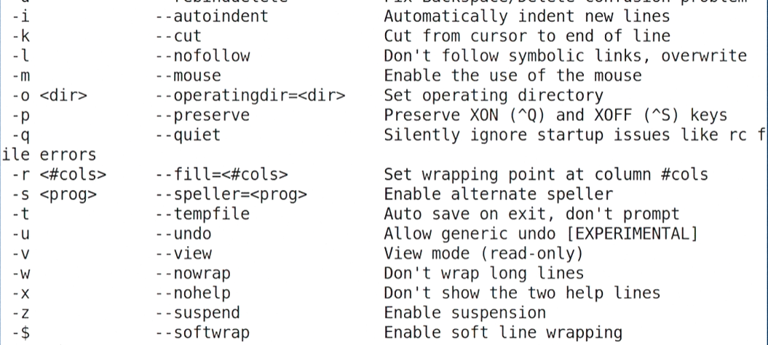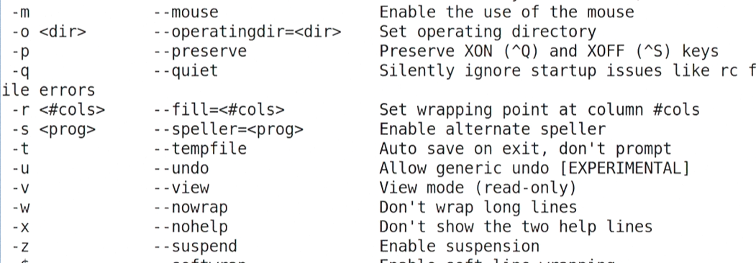

**Here clearly, if wanted to start nano by enabling ‘auto-indent’ and ‘suspension’ we can write command like this,**

**$ nano –iz my_file.txt**

# **Undo and Spell Checking in Nano**

UNDO

* **we can enable undo in nano by starting it with –u(uncut flag)  
  $ nano –u my_file.txt**
* **now we can use ctrl+u to undo something**

**SPELL**

* **for spell checking we can use simple program “spell” in linux**

**to install**

**$ sudo apt-get install spell**

* **now whenever we type wrong and use ctrl+t nano will notify us and let us to replace it by prompting.**
* **“Spell” is very basic so we can use “Aspell” that can be invoked using command line options.(see video)**

# **Customizing Nano Using .nanorc file**

* Like other programs nano also have a .nanorc file both at system level /etc/nanorc

And at use level ~/.nanorc

* We can set some options using ‘set’ command (see video)